# xpedx.com Next generation

# *Entitlements Design Document*

**Authors: Sterling Commerce**

**Date Created:** 04/12/10

**Last Updated:** 6/17/2010

**File Name:** C:\Documents and Settings\bfurman\My Documents\Temp\Methodology v1.1\Project Management\TEMPLATE - DOCUMENT - Use Case Definition.docxpedx Entitlements Detail Design Doc V1.4.docx

Approval Signatures (Mandatory)

|  |  |  |  |  |
| --- | --- | --- | --- | --- |
| **Title** | **Name** | **Signature** | **Date** | **Comments / Issues / Concerns** |
| **xpedx Owner(s)** | Steve Bugher |  |  |  |
| Cheryl Tullis |  |  |  |
| **Sterling Commerce Owner(s)** | Guy Read |  |  |  |
|  |  |  |  |

**Note**: The sign off indicates approval of all sections of the document.

Document Revision History

This chart tracks the changes introduced by the revisions to the document as the project progresses through the stages of the System Development Life Cycle (SDLC).

| Version | **Date** | **Description (Changes Made)** | **Author(s)** |
| --- | --- | --- | --- |
| 1.0 | 04/24/2010 | Initial Draft | Sterling |
| 1.1 | 05/25/2010 | Updated based on feedback dated 05/11/2010 | Sterling |
| 1.2 | 06/04/2010 | Updated based on feedback dated 20100603. Cleaned up document to remove previous track changes. | Sterling |
| 1.3 | 06/11/2010 | Updated based on meeting 6/9/2010 | Sterling |
| 1.4 | 06/17/2010 | Including Connectivity Diagram | Sterling |

Related or Reference Documents

| Document Name | Description | Owner | Location |
| --- | --- | --- | --- |
| SCI_Xpedx Solution Definition Document v1.5 | Solution Definition document | Sterling Commerce |  |
|  |  |  |  |

TABLE OF CONTENTS

1. Introduction 4

1.1 Document Purpose 4

1.2 Document Audience 4

2 Entitlements 5

2.1 Functions & Solution 5

2.1.1 Customer Entitlement Rules 5

2.1.2 Assign Customers to Entitlements 6

2.1.3 Entitlement Naming Convention 6

2.2 Master System 7

2.3 Implementation Details 7

2.3.1 Sample Entitlement Definition 7

2.3.2 Entity objects. 8

2.3.3 Actions involved and Functions 8

2.4 Process Flow 8

2.5 Screen Shot 9

2.6 Open Questions 9

2.7 Assumptions 9

3 Connectivity Diagram 10

4 Glossary of Terms 11

# Introduction

## Document Purpose

This document is the governing functional design document for the entitlements functionality. It presents significant decisions and constructs used in developing the functionality. Testing, builds, configuration management are not covered in this document.

The document will also serve the purpose of keeping a list of assumptions that were made during design discussions.

## Document Audience

This document is intended for management and technical staff working on this project, xpedx IT and Business, webMethods, Legacy(MAX and ACCESS), HP, IW, xpedx/IP Network Team. Sterling will use the document during design and configuration for design consideration.

# Entitlements

## Functions & Solution

Entitlements are used to determine the set of items that a customer is able to view/buy. An Entitlement is a list of items that are assigned to customers. The rest of the document refers to these as Customer Entitlements.

The Sterling product allows entitlements to be managed via a few different strategies -

1. Customers can access only the items that are directly assigned to them in customer entitlements.
2. Customers can access only the items that are assigned to them in pricelists.
3. Customers can access only the items that are assigned to them in both pricelists and customer entitlements.
4. Customers can access all items regardless of pricelists and customer entitlement.

## Customer Entitlement Rules

Customer entitlement rules specify the set of items that comprise the entitlement. Only items from the online catalog can be specified under customer entitlement rules. A customer entitlement contains one or more customer entitlement rules that collectively define the list of items for the entitlement.

To define a rule, start with no categories and then add customer entitlement rules to include items; or start with all items in your online catalog and add customer entitlement rules to exclude items. Items can be specified individually, by categories of items, or by item attributes.

In Sterling items that a customer is entitled to, are a union of all entitlements that are assigned to the customer, either directly or via some rules. There is no support to define an entitlement based on another entitlement. ( e.g. Create a new entitlement that starts by including the group entitlement and then selectively remove some categories).

Five major types of Entitlements in the system

1. Group Entitlements – Assignments are managed by Sterling. If a pricing warehouse on a customer record changes, the group entitlement is automatically updated by Sterling.
2. Division Entitlements – Assignments managed via Sterling Business Center
3. Brand Entitlements - – Assignments managed via Sterling Business Center
4. Customer Specific Entitlements – Assignments managed via the Entitlement Configurator
5. Anonymous Entitlements – Assignments managed via the Sterling Business Center.

There is no customization of the out-of-box entitlement engine functionality in Sterling. The assumption is that the entitlements will flow into the system using the format specified by Sterling.

At xpedx, the Customer Entitlement Rules are all modeled as a list of Item Ids. The current understanding is that Sterling features like entitlements based on item attributes/item categories will not be fed via the entitlement interface. If used, these will be managed via the Sterling Business Center.

## Assign Customers to Entitlements

Once the set of items that make up an entitlement have been defined, the entitlement is assigned to the customers using either customer attributes or directly to customers. Entitlements will be tied directly to the customer ship-tos in the xpedx solution.

At xpedx, there are three types of entitlement to customer assignments.

Managed by the Sterling load process (e.g. Group Entitlements).

Managed via Sterling Business Center (e.g. Divisional Entitlements).

Managed by the Entitlement Configurator (e.g. Customer Specific Entitlements).

The Group Entitlements and Divisional Entitlements are loaded into Sterling with only their list of items populated. There is no customer assignment section.

The Customer Specific Entitlements specify the customer assignment portion as well. They list out all the Ship-Tos that the entitlement is to be assigned to. This in turn implies that the customer Shipt-Tos should exist in the system before the Customer Specific Entitlements are loaded.

Based on this, the sequence of entitlement related data loads is defined as follows –

1. Group Entitlements (initial load)
2. Customer Batch
3. All Entitlements (including Group, Division, Customer Specific, etc.)

For regular maintenance, Steps 2 and 3 are repeated in sequence.

When customers are loaded via the batch feed, Sterling will assign entitlements to customer ship-tos using the following business rules -

1. When a new customer ship-to is added to Sterling or an existing ship-tos pricing warehouse is changed -
   1. Determine if the ship-to is currently assigned to any group entitlement. If yes, un- assign existing group entitlement and assign new default group entitlements driven by the pricing warehouse on the customer account record. In the case of new shipto’s there will be no existing group entitlements assigned and hence only the new group entitlement is assigned to it.
2. Customer specific entitlements are assigned automatically by the Entitlement rules engine to the appropriate ship-tos based on the data that was loaded from Entitlement Configurator. This is also driven by the customer ship-to account number.
3. Any division/brand entitlement will be assigned manually using the Sterling Business Center.

The anonymous user experience will need to be setup in Sterling Business Center right from start. The anonymous user experience will be assigned to the Anonymous Entitlements

## Entitlement Naming Convention

This section defines the exact format of the Entitlement ID field so that auto assignment to customers can take place. This is based on discussions about the Entitlement Configurator output to Sterling.

The current understanding is that there will be one entitlement per group, one entitlement per division and possibly several entitlements per customer that are loaded in Sterling via the interfaces. The Customer specific entitlements are sent with all the related ship-to information populated.

The Naming convention for these entitlements is as follows -

Group Entitlement

GROUP_<Environment ID>_<Pricing Warehouse>

Division Entitlement

DIVISION_<Environment ID>_<Division Number>

Customer Entitlement

CUSTOMER_<Environment ID> <Customer Division>_<Legacy Customer Number>__<Seq No>

## Master System

Sterling is the system of record for Entitlements.

## Implementation Details

## Sample Entitlement Definition with No Customer Assignment

The following is a sample of an entitlement that is created in Sterling with the following selections

1. Exclude All Items

2. Add specific Items (not catalog).

2255240

2255211

100019641

Q1956A

3. Assign to customers with Specific Attributes

Customer Level=Preferred, Key

Customer Vertical=Manufacturing

Relationship Type =Cold Weather Customer

<EntitlementRule

**Description**="Exclude All Items&#xd;&#xa;Include Specific Items&#xd;&#xa;Assign to Customers with Attr."

**EffectiveFromDate**="2010-04-01"

**EffectiveToDate**="2010-04-10"

**EntitlementRuleID="WinTestEntitlement3"**

IgnoreOrdering="Y"

OrganizationCode="XPEDX"

Purpose="BUYING"

**StartWithAllCatalogItems="N"**>

<EntitlementRuleDetailList Reset="Y">

<EntitlementRuleDetail InclusionFlag="Y" SequenceNo="1" SourceType="03">

<EntitlementRuleDetailItemList Reset="Y">

<EntitlementRuleDetailItem **ItemID="2255240"** UnitOfMeasure="Each"/>

<EntitlementRuleDetailItem **ItemID="2255211"** UnitOfMeasure="Each"/>

<EntitlementRuleDetailItem **ItemID="100019641"** UnitOfMeasure="Each"/>

<EntitlementRuleDetailItem **ItemID="Q1956A"** UnitOfMeasure="Each"/>

</EntitlementRuleDetailItemList>

</EntitlementRuleDetail>

</EntitlementRuleDetailList>

</EntitlementRule>

## Sample Entitlement Definition with Customer Assignment

The following is a sample of an entitlement that is created in Sterling with the following selections

1. Exclude All Items

2. Add specific Items (not catalog).

1042058

1042532

1042718

3. Assign to specific customers

CustBBURKIN

CustCKLUES1

CustWEDWA11

<EntitlementRule Description="WinTestRule"

EffectiveFromDate="2010-06-01" EffectiveToDate="2110-06-06"

EntitlementRuleID="WinTestRule" IgnoreOrdering="Y"

OrganizationCode="xpedxDemo" Purpose="BUYING" StartWithAllCatalogItems="N">

<EntitlementRuleDetailList Reset="Y">

<EntitlementRuleDetail InclusionFlag="Y" SequenceNo="1" SourceType="03">

<EntitlementRuleDetailItemList Reset="Y">

<EntitlementRuleDetailItem ItemID="1042058" UnitOfMeasure="EACH"/>

<EntitlementRuleDetailItem ItemID="1042532" UnitOfMeasure="EACH"/>

<EntitlementRuleDetailItem ItemID="1042718" UnitOfMeasure="EACH"/>

</EntitlementRuleDetailItemList>

</EntitlementRuleDetail>

</EntitlementRuleDetailList>

<EntitlementRuleAssignmentList Reset="Y">

<EntitlementRuleAssignment CustomerID="CustBBURKIN" EntitlementRuleAssignmentKey="2010060916253733830"/>

<EntitlementRuleAssignment CustomerID="CustCKLUES1" EntitlementRuleAssignmentKey="2010060916253733833"/>

<EntitlementRuleAssignment CustomerID="CustWEDWA11" EntitlementRuleAssignmentKey="2010060916253833835"/>

</EntitlementRuleAssignmentList>

</EntitlementRule>

## Entity objects.

## Actions involved and Functions

## Process Flow

## Screen Shot

This is a screenshot of an entitlement created using the Sterling Business Center. It shows an entitlement that includes a category and all items with a specific value.

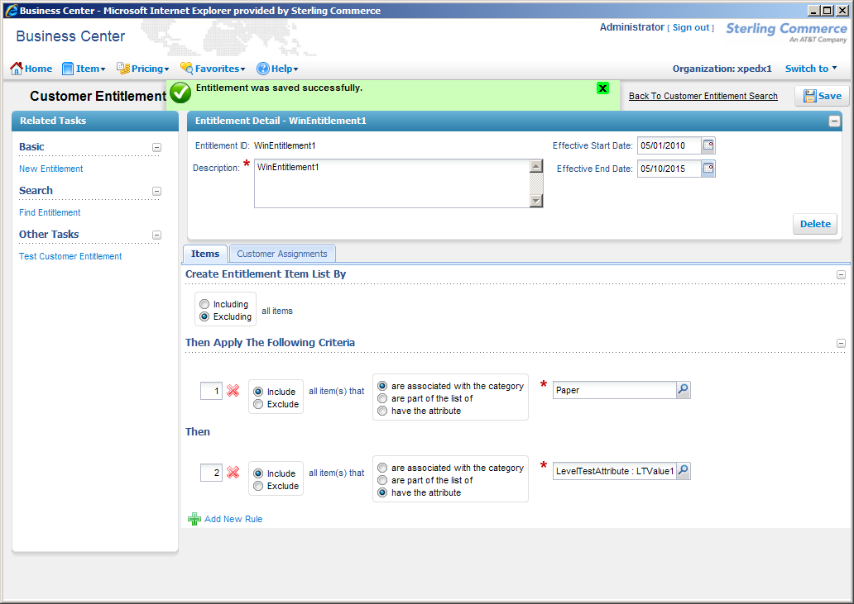

## Open Questions

1. The discussion on the output of the Entitlement Configurator, that is fed into Sterling is still pending. We’ve been told that this might not happen till much later. Resolved – see assumptions 1 thru 3.
2. How do we identify the customer specific entitlement vs a Group entitlement? Resolved – See 2.1.3. – Entitlement Naming Convention.
3. Connectivity Diagram

## Assumptions

1. There will be no brand entitlements in the system. Only three types of entitlements will be fed into the system via interfaces – Group, Division and Customer.
2. Anonymous entitlements will be created and maintained using Sterling Business Center.
3. Non-default assignment of entitlements will be handled via Sterling Business Center.

# Connectivity Diagram

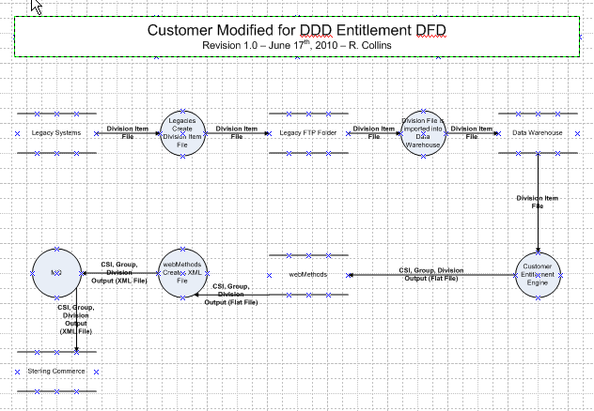

# Glossary of Terms

|  |  |  |
| --- | --- | --- |
| S. No. | Term | Definition |
| 1. | WSDL | Web Services Definition Language |
| 2. | UE (User Exit) | Hooks to write custom code in Sterling |
| 3. | MQ | Message Queue |
| 4. | BR1 | Business Release 1 |
| 5. | IW | Industrial Wisdom – UI firm engaged on the project. |
|  |  |  |
|  |  |  |